Lab: Gosu Enhancements

In this lab you will create methods that automate responses to specific actions.

Overview

At Acme Insurance, ABContacts should get a courtesy call once every six months. During that courtesy call, the Acme representative may determine that the ABContact should be considered a strategic partner.

Tasks

1. Create an enhancement property for ABContact that returns the date of the next courtesy contact. Use the following logic:

* If Last Courtesy Contact is null, then return null.
* If Last Courtesy Contact is not null, then return the date 180 days after the Last Courtesy Contact date.

1. Add a widget to ABContactAnalysisDV that displays the date for the next courtesy contact. The date should be formatted as shown below. Test the enhancement twice: once by setting the Last Courtesy Contact field to January 01 of the current year, and once using June 01 of the current year.

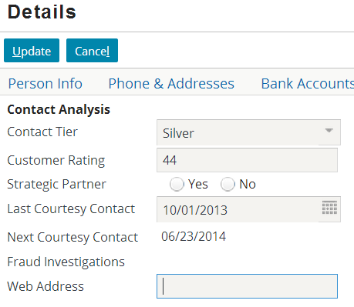

1. Create an enhancement method for ABContact that designates a contact as a strategic partner if the contact is not already a strategic partner. Include the following actions:

* Set the Strategic Partner flag to true.
* Add 10 to the Customer Rating (if it is not null), or set it to 25 (if it is null).

1. Modify the ABContactAnalysis screen visible on the Analysis page so that:

* There is a toolbar button labeled "Upgrade to Strategic Partner". It is available only in edit mode and only for partners who are not already strategic partners. When clicked, it executes the strategic partner enhancement.
* The current input field "Strategic Partner" is read-only (so that the field is now set only by the toolbar button).

HINT 1: You will edit this file:



HINT 2: Use a regular input button for the “Next Courtesy Contact

HINT 3: The screenshots give you an idea of how the new button should work.

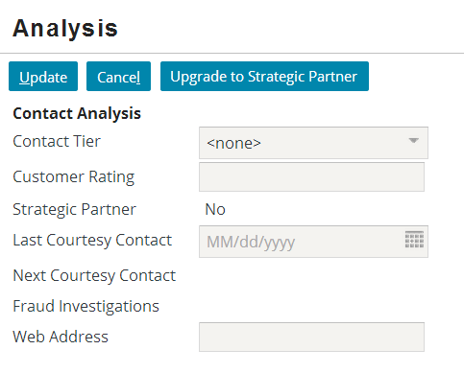 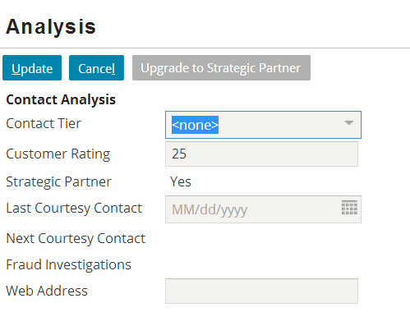

Verification

1. Do the following to test the strategic partner enhancement:
   1. View the Analysis screen in read-only mode and verify that the button is not available.
   2. View the Analysis screen in edit mode and verify that the button is available.
   3. Click the button for a non-strategic partner with no customer rating score. Verify that the contact is upgraded to a strategic partner and the customer rating is set to 25.
   4. View the button for a strategic partner. Verify that the button is not available.
   5. If time permits, temporarily modify the Strategic Partner field so that it is editable. For a given contact, set Strategic Partner to false and Customer Rating to 50. Then, click the button and verify that the Strategic Partner was set to true and the customer rating was changed to 60. When you are done, change the Strategic Partner field so that it is no longer editable.

|  |  |
| --- | --- |
|  | Stop and ask your instructor to review your completed lab. |